July 30, 2018

The Honorable Joseph Graves
Chairman, Oversight Committee
S-985 House Office Building
Lansing, MI 48933

Dear Chairman Graves,

I am writing today to respectfully request an immediate hearing regarding the PFAS contamination in Kalamazoo County. Because of recent media reports, families across Michigan are concerned for the safety of their drinking water. As the Oversight Committee, we have an opportunity to help assuage these fears while getting to the truth about what happened leading up to and during the current crisis.

We have reached the point where the DEQ needs to be brought in for questioning. Multiple PFAS problems throughout the state, coupled with the current spread from Parchment to other cities in Kalamazoo County, have made it clear that the department is still not properly prepared to handle these continual crises in an effective manner. Beyond this, the department’s record of not being forthright on when they were initially informed of problems leaves me deeply concerned that the public, including affected citizens, may not have been made aware of this issue until it was far too late.

Therefore, I ask that we as an Oversight Committee complete our due diligence in assessing and auditing the DEQ for its response to the ongoing PFAS problems in our state.

Respectfully,

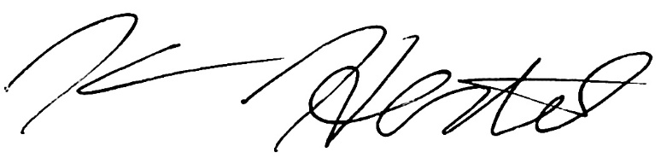

Kevin Hertel
State Representative
District 18

