Information on Michigan’s Work Search Requirements
- To continue to receive unemployment benefits you are required to report at least one work search activity per week during your bi-weekly certification for benefits.
- Your benefits will not be paid until your work search activities have been reported.
- The first time you are required to include the details of your work search activity is when you certify for the week ending June 5, 2021.
- You can submit work search requirements online through MiWAM or by phone with MARVIN at 866-638-3993.
- If you are certifying by phone, you must certify on your scheduled certification day and time. This is based on your social security number. Certify by answering the questions and then stay on the line.
- Information you will need to submit a work search; when you searched, what the activity was, who you spoke with or what you used, how you completed the work search.
- You should keep records of your work searches in case of a review by UIA.
- Some people are eligible for work search waivers if there is a COVID-19 related reason, you have been temporarily laid off, or you are a student/in a training program.
- If you are submitting a waiver, you must apply and be approved for the waiver before you certify for benefits for the bi-weekly certification period.
- You will be notified at the time of the request whether a waiver of the requirement is granted.
- You must still complete a work search even if you have a job waiting unless you have a waiver.
- To find answers to specific questions, visit michigan.gov/uia and read the frequently asked questions.
- Please continue to check the UIA website at michigan.gov/uia for updates on Michigan’s work search requirements.

Detailed Information on Michigan’s Work Search Requirements
Do I have to submit a work search requirement?
Reporting your work search activities will be required for most claimants receiving unemployment benefits. If you have an approved waiver, the work search requirement is waived.
You can report your work search online via MiWAM or by phone.
Online with MiWAM
- Enter your work search activity in MiWAM at Michigan.gov/uia.
- Questions about your work search will be included with your regular certification questions.
- Enter the details of your Work Search Activity for Week 1 and Week 2.
- Certify with MiWAM any day during your certification week.
Calling in by Phone
- Certify by phone with MARVIN at 866-638-3993. Listen carefully to the prompts and answer the certification questions.
- After completing the automated questions, you must stay on the line to be connected with an agent to provide the details of your work search.
- Do not hang up before you have provided your work search details or your certification will not be complete, and your benefits will not be paid.
Beginning June 7, 2021, if certifying by phone, you must certify on your scheduled certification day and time. Your certification day and time are scheduled according to the last two digits of your Social Security Number.
Example: If your Social Security Number is 555-55-5511, the last two digits are 11. The appointment time for number 11 is Monday between 8:00 a.m. and 12:30 p.m. Eastern Standard Time.
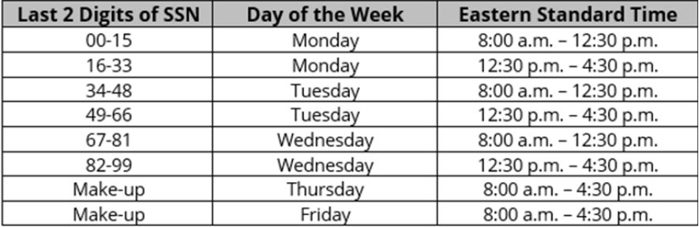

What do I include when submitting my work search requirements?
- Date of Contact – The day you searched for work.
  - Example: May 25th, 2021.
- Activity - Enter the work search activity for the week you are claiming benefits. Currently, only one activity for each week is required.
  - Examples: Submitted an online application, checked resources at employment offices, checked job listings at Michigan Works, went to a job fair.
- Name of Employer/Organization/Search Engine - Write the name, if known, or the online job search site, or employment service or agency that was contacted.
  - Example: State of Michigan Jobs Page
- Employer Address/Online Location - Enter the location where work was sought, physical address or online website address. If the contact was made by telephone or fax, enter the phone number.
  - Example: https://www.governmentjobs.com/careers/michigan
- Method of Contact - Enter how contact was made.
  - Examples: Online, email, in person, phone, mail, fax.
What work search waivers are available?
Temporary Layoff - Registration and Seeking Work Waiver
If you are expected to return to full-time work with your employer within 45 days from the date you filed or reopened your claim, your employer can request that you be waived from the work search requirements. The employer is required to request this waiver before laying off workers. If an employer has requested and been approved for a 45-day waiver, your determination will state that you have been waived from the work search requirement.
Temporary Layoff - Short-Term Waiver
If you are laid off and expect to return to work within 15 days of your layoff date, you can apply for a work search waiver at the time you file your claim. If approved, your determination will state that you have been waived from the work search requirement.

School/Training Waiver
If you are in school attending an approved course of study, you may qualify for a training waiver which also waives the work search requirement. To apply for a training waiver, you must contact a Michigan Works! Office. Michigan Works will assist you with the application submission to UIA. If approved, the work search requirement will be waived. Call your Local Michigan Works! One-Stop Service Center at 800-285-WORKS (9675).
COVID-19 Related Waiver
The following are reasons you may be eligible for a COVID-19 waiver:
- You have a current COVID-19 diagnosis within the last 14 days.
- Someone in your household has a current diagnosis of COVID-19 within the last 14 days.
- You are providing care for a family member or someone in your household who has been diagnosed with COVID-19 within the last 14 days.
- You had COVID-19, and because of health complications you can no longer perform your job.
  - This includes people whose employers have offered reasonable accommodations.
- You are under self-isolation or self-quarantine in response to an elevated risk from COVID-19.
- A child or another person in the household is unable to return to a school or care facility like a preschool, daycare, or adult daycare and you are responsible for taking care of them.
  - Your waiver will only be approved if the facility does not offer a 100% in person option. If the facility offers a hybrid option, with some in person activities and some online, you are eligible for a waiver.
- You cannot work because a doctor has told you that you should to self-quarantine due to concerns related to COVID-19.
- You are receiving Pandemic Unemployment Assistance (PUA) and you are self-employed or an independent contractor.
Commonly Asked Questions
Do I need to keep records of my work searches?
Yes. UIA can request to verify your work search activities at any point during your claim. If your activities are found to be incomplete or inaccurate, you may be ineligible and have to pay back benefits. Save all confirmation emails or documentation to prove your work search activity. This information should be retained for up to 2 years.
Do I need to accept any job offer I receive?
You must accept an offer of work if, based on your skills, abilities, and other factors such as pay amounts, it is a suitable job that meets your needs.
Can I just apply for the same job more than once?
No. You cannot apply for the same job more than once in a four week period and have it count.
If I have a job and I’m just waiting for it to start again, do I need to complete a work search requirement?
If you are laid off and expected to return to full-time work with your employer within 45 days from the date you filed or reopened your claim, your employer can request that you be waived from the work search requirements. If you are laid off and expect to return to work within 15 days of your layoff date, you can apply for a work search waiver at the time you file your claim.
If you have a job waiting and are not eligible for a waiver, you must still complete the work search requirements. The work search requirements are not specific to COVID-19 and are required at other times as well.
If I am receiving PUA and am self employed, do I need to fill out a waiver?
No. A waiver will be automatically granted.
What is not valid work search activity?
Applying for the same job more than once within a 4-week period or calling to see if there are any jobs available does not count as a work search. Browsing job boards does not count unless you submit an actual application. For more information, visit Michigan.gov/uia
Does being afraid of COVID-19 count as a good reason to claim unemployment benefits?
No. You must fall into an eligible category to claim unemployment.
My employer received a loan and is now going to pay me for weeks when I received unemployment benefits. What should I do?
You must notify the Agency about the back pay. You will likely pay back the unemployment benefits you received for the weeks you received the back pay.
What do I do if I feel my workplace is not following COVID-19 rules/is not safe?
All employees have a right to raise a safety or health concern with their employer or MIOSHA, and to file a complaint with MIOHSA. An employer cannot retaliate against an employee for complaining about a safety or health condition in the workplace or refusing to do an allegedly imminently dangerous job or task. For more information, employees should review resources on MIOSHA’s website or contact MIOSHA using the new hotline at 855-SAFEC19 (855-723-3219).
What should I do if my employer calls me back to work and I say no?
You should indicate on your biweekly certification through your MiWAM Account that your employer offered you to return to work and that you refused to return to work. You should include the reason(s) for refusing to return to work with as much detail as you can provide. If you do not have a ‘good cause’ reason, you will be disqualified and will not be eligible for unemployment.
Where can I find a detailed list of work search activities and examples?
Visit: https://bit.ly/3icYfzh
Where should I go to see the most up to date information regarding unemployment?
Visit Michigan.Gov/UIA

